ODIR-5K Retinal Fundus Image Classification
Normal vs. Disease Screening — Project Report
Educational proof-of-concept · Deep learning · Transfer learning · Clinically meaningful evaluation
Repository: github.com/GokulRaj0110/CGNT_Discoverathon

1. Executive Summary
This project builds a binary screening classifier that labels a retinal fundus photograph as Normal (0) or Disease sample (1), using the ODIR-5K dataset (5,000 patients, paired left/right fundus images, eight original diagnostic categories collapsed into a binary target). The goal was educational: to practice transfer learning, patient-level data splitting, class-imbalance handling, and clinically meaningful evaluation rather than to build a deployable diagnostic tool.
The final pipeline fine-tunes a pretrained ResNet50 backbone with a custom binary classification head, trained across a 5-fold patient-level StratifiedGroupKFold split. The out-of-fold (OOF) results across all 5 folds were:
Metric | Value
ROC-AUC (primary) | 0.8218 (per-fold mean 0.8247 ± 0.0133)
F1 Score | 0.7605
Accuracy | 0.7473
Sensitivity (Disease recall) | 0.7112
Specificity (Normal recall) | 0.7939

The most notable methodological contribution in this work is the training schedule: instead of unfreezing the entire pretrained backbone at once, the backbone is unfrozen gradually, one group of layers at a time, over the course of training. This was implemented as a deliberate change after an earlier all-at-once unfreezing approach showed heavy overfitting. Overfitting is reduced but not eliminated under the new schedule — this is discussed in Section 6.

2. Background and Objective
Retinal fundus imaging is a non-invasive, standardized way of capturing signs of diabetic retinopathy, glaucoma, age-related macular degeneration (AMD), cataract, hypertension, myopia, and other ocular disorders. An automated first-pass triage model — one that flags a fundus photo as "needs clinician review" versus "looks normal" — could help prioritize review queues in high-volume screening settings.
The objective set for this exercise was to:
- Classify each fundus image as 0 = Normal or 1 = Disease sample (any non-normal finding).
- Use transfer learning from an ImageNet-pretrained backbone, appropriate given the limited size of labeled medical imaging data.
- Build a robust preprocessing and training pipeline that explicitly handles class imbalance.
- Split data at the patient level so that a single patient's left/right eye images never leak across train and validation.
- Report clinically relevant metrics — sensitivity, specificity, F1, confusion matrix, and ROC-AUC as the primary metric — alongside plain accuracy.
- Where possible, gain insight into model failures via Grad-CAM explainability.

3. Dataset
The project uses the Kaggle dataset andrewmvd/ocular-disease-recognition-odir5k, which contains fundus photographs and annotator labels for approximately 5,000 patients (both eyes), covering eight categories: Normal (N), Diabetes (D), Glaucoma (G), Cataract (C), AMD (A), Hypertension (H), Myopia (M), and Other (O). Labels were quality-controlled by ophthalmologists, and images come from multiple hospitals and camera systems, introducing realistic multi-site variability.
For this project, the eight diagnostic categories were collapsed into a binary target: Normal → 0, any disease category → 1. Binary labels were built primarily from full_df.csv, falling back to the patient-level data.xlsx metadata where needed.
Out-of-fold class support (5-fold OOF evaluation set, N = 7,000 images):
Class | Support
Normal | 3,052
Disease | 3,948
Total | 7,000

4. Methodology

4.1 Preprocessing
- CLAHE (Contrast-Limited Adaptive Histogram Equalization), applied because it is well suited to fundus photographs where lesions and vessels can be low-contrast against the retinal background.
- Standard ImageNet normalization to match the statistics the pretrained backbone was trained on.

4.2 Patient-Level, Leakage-Checked Splitting
Because ODIR-5K provides two images (left and right eye) per patient, a naive random split can place both eyes of the same patient into different folds — leaking patient-specific anatomy and imaging conditions between train and validation and inflating validation performance. To avoid this, the data was split using a 5-fold StratifiedGroupKFold, grouped by patient ID and stratified on the binary label, with an explicit leakage check confirming no patient's images ever appear in both the training and validation portions of the same fold.

4.3 Augmentation and Class Balancing
- Augmentation: random crop, horizontal flip, rotation, color jitter, and RandomErasing, to improve robustness to the multi-camera, multi-site variability in the dataset.
- Class balancing: a WeightedRandomSampler oversamples the minority class during training, complementing (rather than replacing) the loss-level handling of imbalance.

4.4 Model Architecture
A pretrained ResNet50 backbone (ImageNet weights) is used as a feature extractor, with the original classification layer replaced by a custom binary head (fully-connected layers with dropout, HEAD_DROPOUT = 0.4, ending in a single sigmoid output representing P(disease)).

4.5 Training Strategy — Gradual Group-by-Group Unfreezing
The training schedule was the main area of iteration in this project, and reflects a deliberate design choice: rather than unfreezing the entire backbone at once after a brief warm-up (the initial approach), the backbone is unfrozen gradually, one group of layers per stage, across training. This was implemented and tuned directly (with the general strategy discussed with an LLM assistant, see Section 9) after observing that all-at-once unfreezing caused training loss to fall toward zero while validation loss climbed for the back half of every fold's run — a clear overfitting signature.
The final schedule works as follows:
- Stage 0 — freeze the entire backbone and train only the classification head for FREEZE_EPOCHS epochs, letting the head adapt to fundus images before touching pretrained features.
- Stage 1..N — unfreeze one backbone group at a time, output-side first (the group nearest the head opens first, the input stem opens last), every EPOCHS_PER_UNFREEZE_GROUP epochs.
- Discriminative learning rates — each newly-opened group gets a smaller learning rate than the group opened before it (decayed by UNFREEZE_LR_DECAY per step), so deeper, more task-specific layers adapt faster than shallow, generic ones.
- Stem override — once the input stem (low-level edge/color filters) finally unfreezes, it is given an explicit, very small learning rate (FINAL_STAGE_LR) rather than continuing the normal decay, since low-level filters rarely benefit from aggressive updates.
- ReduceLROnPlateau (monitoring validation AUC) runs within each stage, and training early-stops per fold if validation AUC has not improved for EARLY_STOP_PATIENCE epochs.

Key hyperparameters:
Parameter | Value | Meaning
N_UNFREEZE_GROUPS | 4 | Number of backbone chunks the unfreeze is staged across
EPOCHS_PER_UNFREEZE_GROUP | 3 | Epochs between successive unfreeze events
UNFREEZE_LR_DECAY | 0.5 | Per-group learning-rate decay (stem is overridden, not decayed)
FINAL_STAGE_LR | 5e-5 | Explicit learning rate for the stem once it unfreezes
EARLY_STOP_PATIENCE | 6 | Epochs without val-AUC improvement before a fold stops
WEIGHT_DECAY | 3e-4 | L2 regularization
HEAD_DROPOUT | 0.4 | Dropout in the classification head

4.6 Evaluation Protocol
Each of the 5 folds produces a best checkpoint (selected on validation AUC). Metrics reported in Section 5 are out-of-fold (OOF) — every image's prediction comes from the fold in which it was held out, so the reported numbers are not inflated by the model having seen that image during training of any ensemble member. For inference on the unlabeled ODIR-5K test images, the 5 fold checkpoints are ensembled to produce final probabilities.

5. Results

5.1 Overall Performance (Out-of-Fold)
Metric | Overall (OOF) | Per-Fold Mean ± Std
ROC-AUC (primary) | 0.8218 | 0.8247 ± 0.0133
F1 Score | 0.7605 | —
Accuracy | 0.7473 | —
Sensitivity (Disease recall) | 0.7112 | —
Specificity (Normal recall) | 0.7939 | —
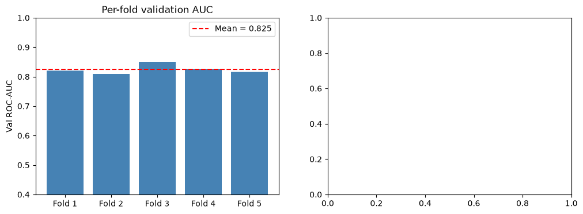
Figure 1. Per-fold validation ROC-AUC across the 5-fold StratifiedGroupKFold split (mean = 0.825).

5.2 Per-Class Breakdown
Class | Precision | Recall | F1-Score | Support
Normal | 0.68 | 0.79 | 0.73 | 3,052
Disease | 0.82 | 0.71 | 0.76 | 3,948
Macro Average | 0.75 | 0.75 | 0.75 | 7,000
Weighted Average | 0.76 | 0.75 | 0.75 | 7,000

At the default decision threshold (t = 0.5), the model favors specificity over sensitivity — it is more likely to correctly clear a Normal image than to correctly flag a Disease image (0.79 vs. 0.71 recall). For a screening/triage use case, where missing disease is typically costlier than a false alarm, this suggests the operating threshold should be tuned downward (trading some specificity for higher sensitivity) before this kind of model is used to inform any real triage decision — even in a non-clinical prototype.

5.3 Confusion Matrix and ROC Curve
The out-of-fold confusion matrix (N = 7,000, threshold t = 0.5) and the overall OOF ROC curve (AUC = 0.822) are shown below. Both are consistent with the precision/recall figures above: most Normal images are correctly cleared, most Disease images are correctly flagged, and the ROC curve sits well above the diagonal chance line across the operating range.
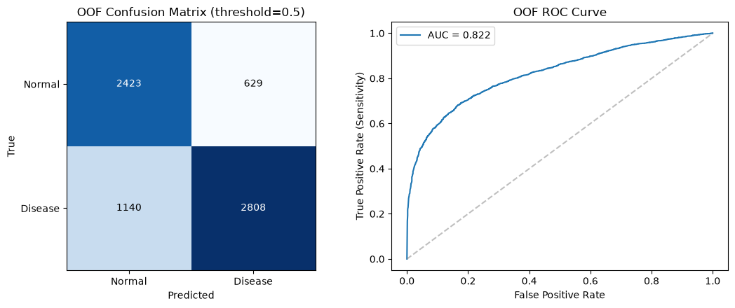
Figure 2. Left: OOF confusion matrix at threshold = 0.5 (2,423 TN, 629 FP, 1,140 FN, 2,808 TP). Right: OOF ROC curve, AUC = 0.822.
Reading the confusion matrix directly: of 3,052 true Normal images, 2,423 were correctly cleared and 629 were incorrectly flagged as disease (false positives). Of 3,948 true Disease images, 2,808 were correctly flagged and 1,140 were missed (false negatives). The false-negative count is the more clinically important error of the two — it is the metric a lower decision threshold would directly target.

5.4 Explainability — Grad-CAM
Grad-CAM was applied to the best-performing fold's checkpoint to visualize which image regions most influenced the model's disease/normal decision. This gives a qualitative check on whether the model is attending to plausible retinal structures (vessels, optic disc, macula) rather than to imaging artifacts, borders, or camera-specific cues — an important sanity check given the multi-hospital, multi-camera nature of the dataset.

5.5 Error Analysis
The most confidently wrong out-of-fold predictions were pulled out and visualized separately, to understand failure modes rather than just the aggregate metrics. This kind of qualitative review is useful for catching systematic issues (e.g., a particular disease subtype the model consistently misses, or an imaging condition that consistently confuses it) that a single OOF ROC-AUC number would hide.

6. Overfitting: Before and After the Unfreezing Change
The first version of the training pipeline unfroze the entire backbone at once after a short head warm-up. That version reliably overfit: training loss fell toward zero while validation loss rose through the back half of every fold's training run, and the best checkpoint consistently landed well before the fixed epoch budget was used, meaning most of the remaining epochs were actively hurting generalization.
Switching to gradual, group-by-group unfreezing (Section 4.5) — implemented and tuned by hand rather than adopting the naive all-at-once approach — measurably reduced this problem. With staged unfreezing, discriminative learning rates, and early stopping tied to validation AUC, the gap between training and validation performance is smaller and more stable across folds (per-fold AUC std of 0.0133), and folds no longer show the same runaway validation-loss climb.
That said, overfitting has not been fully eliminated — it is reduced, not solved. The README for this project notes that if the val-AUC-per-epoch curve still shows a drop right when the final (stem) group unfreezes, the next step to try is reducing N_UNFREEZE_GROUPS to 3, i.e. never unfreezing the stem at all, since low-level edge/color filters learned from ImageNet are unlikely to need task-specific adaptation and are also the most prone to overfitting on a comparatively small, domain-shifted medical dataset.
Other likely levers for further reducing the residual overfitting, not yet fully explored in this project:
- Stronger or fundus-specific augmentation (e.g., mixup/cutmix, or elastic deformation tuned to retinal anatomy).
- Higher weight decay or additional dropout specifically in the later-unfrozen backbone groups.
- Freezing the stem permanently (N_UNFREEZE_GROUPS = 3), as suggested directly in the project notes.
- A held-out, truly external test set (different hospital/camera source) to distinguish genuine overfitting to ODIR-5K's training distribution from overfitting to the validation folds themselves.

7. Limitations, Bias, and Generalizability
- No external test set: all reported metrics are out-of-fold on ODIR-5K itself. They describe generalization within this dataset's distribution of hospitals, cameras, and populations — not necessarily to other imaging setups or patient populations.
- Binary collapse of a multi-label problem: reducing eight diagnostic categories to Normal/Disease means a positive prediction does not indicate which disease is present, and different diseases likely contribute unevenly to both correct detections and errors.
- Threshold sensitivity: the reported sensitivity/specificity trade-off is specific to the default 0.5 threshold; a screening tool would need this threshold deliberately tuned (and re-validated) against the real cost of missed disease versus false alarms.
- Multi-site variability: images come from multiple hospitals and camera systems. Any systematic difference between how those sites' images are distributed across the eight original categories could show up as the model learning site-specific cues rather than purely disease-specific ones; Grad-CAM review helps but does not fully rule this out.
- Screening aid, not a diagnostic tool: this is explicitly an educational proof-of-concept. It is not validated for, and must not be used for, real clinical decision-making.

8. Deliverables Summary
Deliverable | Location / Notes
Notebook / code | notebook.ipynb — full pipeline: labeling, preprocessing, patient-level 5-fold split, augmentation, class balancing, gradual-unfreeze training, evaluation, Grad-CAM, error analysis
requirements.txt | All Python dependencies
Trained model | model.pt (full model) and model_state_dict.pt (state dict) — reproducible checkpoints
Prediction CSV | Predictions.csv — image_id, target (P(disease) ∈ [0,1]) on the test set
Performance metrics | Performance_metrics.txt, Confusion_matrix.png — ROC-AUC, sensitivity, specificity, F1, confusion matrix
Report | This document
Presentation | Accompanying PowerPoint summarizing the implementation

9. Use of AI (LLM) Assistance
In the interest of transparency: this project was completed with the assistance of a large language model (LLM) as a collaborative aid during development — for example, to help think through pipeline structure, debug code, discuss design trade-offs (such as the unfreezing schedule), and draft this report and the accompanying presentation. The core methodological decision to move away from all-at-once backbone unfreezing toward gradual, group-by-group unfreezing with discriminative learning rates was implemented and tuned directly, based on the overfitting observed in the earlier all-at-once version; the LLM's role was assistive rather than a substitute for that experimentation and judgment.

10. Conclusion and Future Work
This project delivers a working, reasonably well-evaluated binary screening classifier for ODIR-5K fundus images (OOF ROC-AUC 0.82), built with a patient-level split to avoid data leakage, class-imbalance handling, and a training schedule — gradual group-by-group backbone unfreezing — that was specifically designed and iterated on to counter an overfitting problem observed in an earlier, simpler training approach. That schedule meaningfully reduced overfitting without fully eliminating it.
Natural next steps, in rough priority order:
- Try N_UNFREEZE_GROUPS = 3 (never unfreeze the stem) and compare validation-AUC-per-epoch curves against the current 4-group schedule.
- Tune the decision threshold explicitly for sensitivity, and report metrics at that operating point alongside the default 0.5 threshold.
- Evaluate on an external, independently sourced fundus dataset to get a genuine read on cross-site generalization.
- Break the binary problem back out into per-disease evaluation, to see which of the eight original categories drive most of the current errors.

